|  |  |
| --- | --- |
| **Data Analysis Final Assignment** | |
|  | |
| Name | Michael Adriel Darmawan |

1. **Business Understanding & Data Understanding**  
     
   Exercise 1.1  
     
   a.   
   For this final assignment, first we need to identify which city district we want to work on. But, from the very beginning, we noticed that there are some noticeable problems with dataset. First of all, there is no single column mentioning city district at all. So, we thought that we can use the latitude and longitude data to find the city district. But it turned out that the latitude and longitude data needed to be fixed as well.  
     
   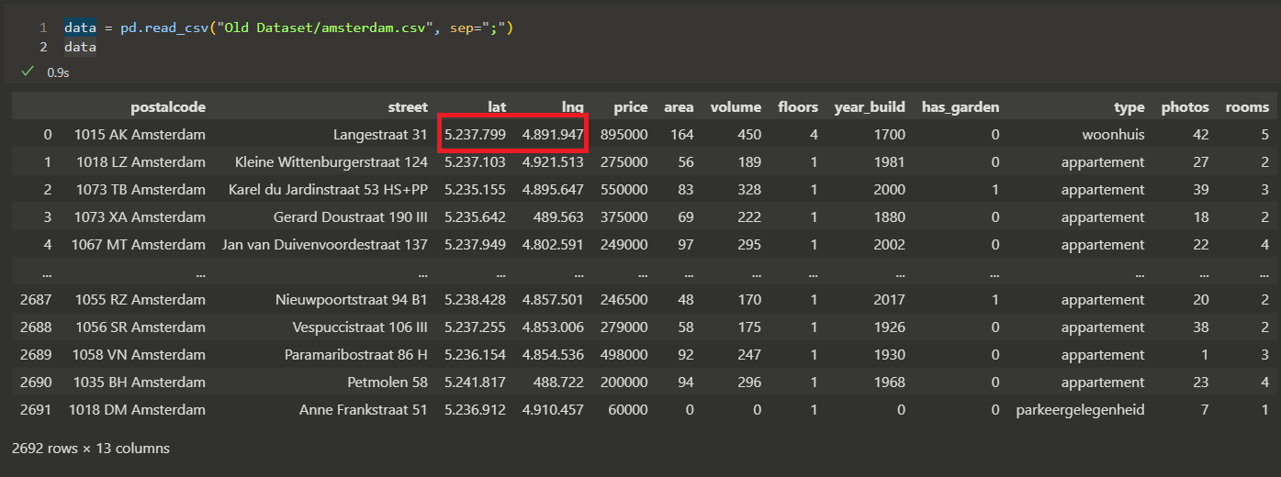  
   Graphical user interface, text, application

   Description automatically generated  
     
   Therefore, we decided to fix the dataset first by using the following steps:  
   1. Using the postalcode data, find the correct latitude and longitude data (using public API -> https://app.zipcodebase.com/api/v1)  
     
   2. Then, from the correct latitude and longitude data get the address details, including the city district that it belongs to (using https://www.geoapify.com/tools/reverse-geocoding-online).  
     
   In the first step, we created a simple python script that iterates each row of the dataset and creates and API call to get the correct latitude and longitude data.  
   Text

   Description automatically generated   
     
   In the second step, we used the <https://www.geoapify.com/tools/reverse-geocoding-online> website to find the address details, resulting in the dataset that now we can use for our data analysis task.  
   Text

   Description automatically generated
2. **Lorem ipsum dolor sit amet, consectetur adipiscing elit. Nulla volutpat nec ipsum non tempus.**   
     
   Etiam et quam at metus bibendum convallis vitae quis ligula. Vivamus imperdiet, magna quis pulvinar commodo, nisl dui vulputate ante, sed lacinia libero velit id magna. Quisque eleifend,
3. **Lorem ipsum dolor sit amet, consectetur adipiscing elit. Nulla volutpat nec ipsum non tempus.**   
     
   Etiam et quam at metus bibendum convallis vitae quis ligula. Vivamus imperdiet, magna quis pulvinar commodo, nisl dui vulputate ante, sed lacinia libero velit id magna. Quisque eleifend, risus ut